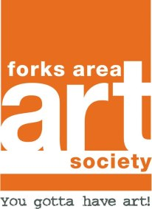
Forks Area Art Society
Membership Application Date______

Annual Membership Dues
Individual: $20 for calendar year
Family: $30 per calendar year

(Dues paid in the month of September will be valid through the following calendar year.)

Name_____________________________________

Address__________________________________

City/State/Zip____________________________

Phone#___________________________________

E-mail address____________________________

Family Membership: Please list immediate family members and provide their email address if they wish to receive our newsletter and periodic updates.

Name Email

Tell us about yourself!

- I am an artist…my medium is_____________
- I am an art appreciator/supporter
- I am an educator
- Other(Care to share?)____________________

Any areas you would like to help with?

Exhibiting • Publicity • Newsletter • Events
Community Support • Volunteering • Fund Raising

Comments or Suggestions?___________________________

Dues received $________ Date Paid________
(form of payment: cash/check)

FAAS 1290 Hawthorn Drive Easton, PA 18040

Check us out on Facebook!

/tmp/in/input.doc

6.12.19

