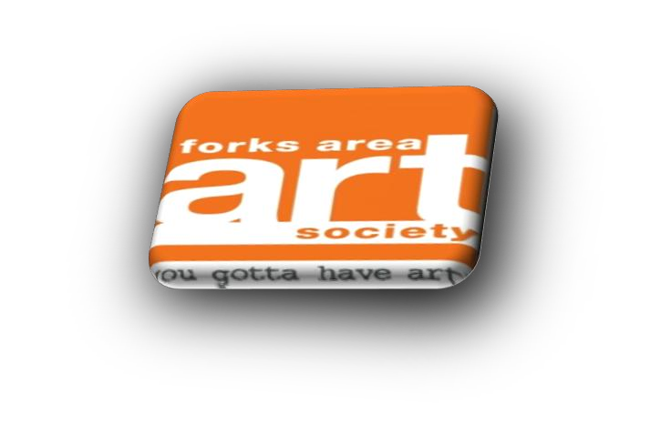
Forks Area Art Society
2024 “Amp Up The Art!”
Art in the Park
Registration Form
Forks Area Art Society is hosting our ninth outdoor art show to promote a creative community gathering of artists. Come join the fun!
Date: Saturday, June 22, 2024 (Rain or Shine)
Time: 10:00 am - 3:00 pm
Where: Meuser Park
2240 Northampton St, Easton PA 18042
Contact: info@forksart.org or call Edie DeProfio at (610) 597-4991.

Welcome Artists/Craftsmen/Vendors! Thank you for joining us at our 9th Annual Art in the Park Event!
Vendor details for 2024 Forks Area Art Society ‘Amp Up The Art’ Art in the Park:
Set-up time: 8:00 am /Break down: 3:00 pm (No one will be allowed on the grounds before this time to set-up).
Registration Fees:
Non-members: $40.00 for each 12x12 space.
Members (2024 dues paid): $30.00 for each 12x12 space.
Food Vendor – Business Flat Fee: $50.00 for each 12x12 space.
Please Note:
* Applications are filled on a first come first served basis
**Only handmade crafts / art (No store bought crafts)
*** FAAS committee will assign booth location(s)
*** Vendors are responsible for providing tents, lights, tables, chairs, and any other items needed
**** In the event of adverse weather please check your email, our Facebook Page, or call the Meuser Park at 610-258-6142
Registration Deadline: June 7, 2024
REFUNDS WILL ONLY BE GRANTED IF WRITTEN NOTICE IS RECEIVED BEFORE June 7, 2024. Upon receipt of your completed application and payment, you will receive an e-mail confirming your space in the park. Please bring it with you when you check-in at the REGISTRATION TABLE upon your arrival.
As a participating artist, craftsman, or vendor you should......
PLEASE READ THE FOLLOWING RULES AND REGULATIONS CAREFULLY:
Wilson Borough Requirements: Art/Craft Vendors: Business license and insurance and Proof of liability insurance. Food Vendors: Evidence of recent food safety inspection, Wilson Borough business license, and proof of liability insurance.
1. You must check in at the registration table and confirm your space upon arrival.
2. Set-up and take down: Set-up time will begin at 8:00am and take-down time will begin at 3:00pm. We kindly ask that all vendors remain open until 3 PM and to please notify the volunteers if you need to leave early.
3. By signing and submitting this application, I/We agree to release and hold harmless to FAAS and its board, staff, Forks Township, related agencies and persons from responsibility for all personal damage to material, equipment, person, lost property or stolen. All booths must be manned for the duration of the event.
- All artists, craftsmen and vendors are responsible for cleaning up their area at completion of event.
5. I/We accept responsibility for submitting all taxes due to the city, state, or federal government.
6. Parking is the responsibility of the vendors and others. All vehicles must be removed from the show area prior to the start of the event and not permitted back into the event area until the end of the show event.
7. Inappropriate behavior will not be tolerated. This includes foul language and harassing other individuals. If you or any members of your team are found to be acting inappropriately, it will result in removal of the individual from the event and closure of your booth without refund. This is to be a fun day for you and all people who are coming to see you and the others.
8. No alcoholic beverages.
9. No overnight campers, vans, trailers, etc., are allowed in the park.
10. There is limited access to electricity. If you require electricity for your booth please let us know when you submit your registration form.
11. You are requested to carry/haul your items to your space and are responsible for cleaning up your area at the completion of the event. Any grease disposal will be the responsibility of the vendor. You may use the parking next to the show while setting up. After set up, move your car or van to one of the other parking lots. Vendors preparing and selling food will be required to have a temporary or permanent food license and Serve Safe certification/insurance. You can contact the department of agriculture at 610-489-1003 or website www.agriculture.state.pa.us.
12. Forks Area Art Society or Meuser Park are not responsible for lost, stolen or damaged material, equipment, or personal property.
Please retain the top portion of this form for your information.

Application Form follows on the next two (2) pages.

2024 Forks Area Art Society “Amp Up The Art!” Art in the Park Saturday June 22, 2024 (Rain or Shine) - 10:00 am - 3:00 pm
Meuser Park, 2240 Northampton St., Easton PA 18042
Please Print. Detach and mail to: Forks Area Art Society, 1290 Hawthorn Dr, Easton PA 18040
Application for vendor space:
Name: __________________________________________
Phone: ( ) _____ - ________
Address: _________________________________________
City: _____________________ State: _________ Zip:__________
Email address____________________________
Check one:
( ) Non-member # ____ of spaces 12x12 @ $40.00 ea
( ) Members (dues paid for 2024) #____ of spaces 12x12 @ $30.00 ea
( ) Food vendor #____ of spaces12x12 @ $50.00 ea
Please make all checks payable to “Forks Area Art Society” Check # _____ Your cancelled check is your receipt. You will also receive a confirmation by email.
Total due $____________
( ) Please check here if you require electricity for your booth.

I have read the rules and regulations and understand that any infraction of them will result in my removal from grounds without a refund.
Signed: _______________________________________________ Date:_________________
**** Please give brief description/photos of the items you will be displaying/selling at Art in the Park

Rev. 3.5.24

